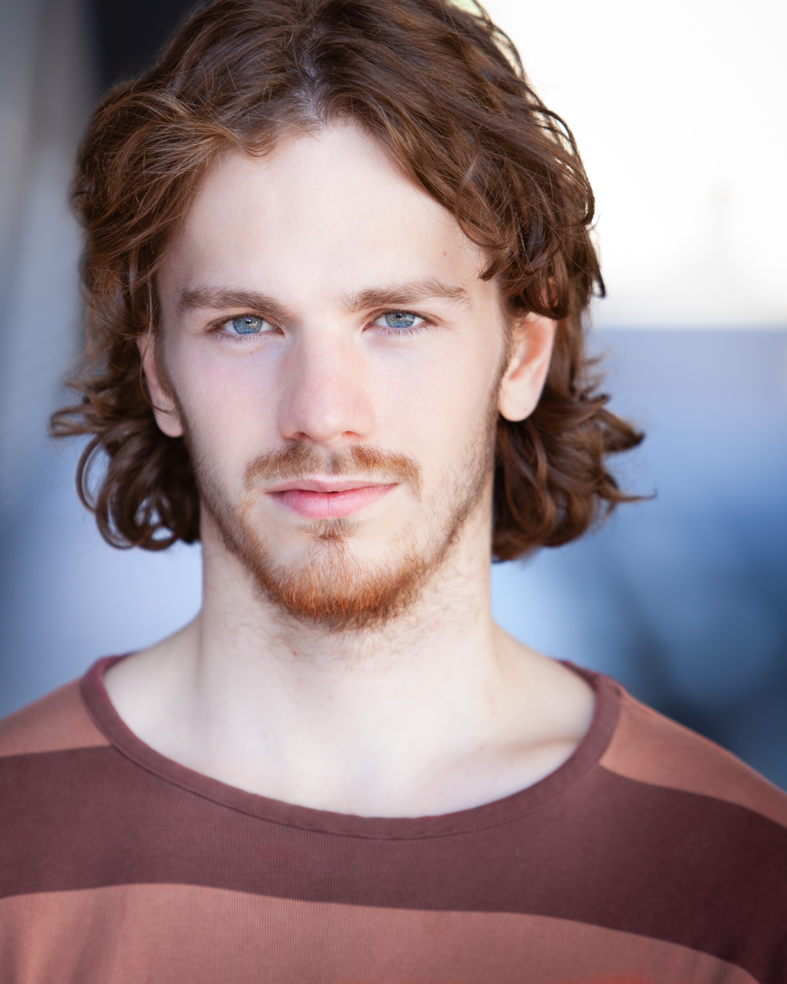
Email: mcrean96@gmail.com
Phone: 07713587977
Theatre

If Mouth Could Speak by Timotei Cobeanu | Director/ Composer/ Sound designer | Sense Assembly – at Edinburgh Fringe ZOO Venues 2019
NUMB | Writer/Director/ Sound-Designer | Sense Assembly
Songs to the Sea (Music-Theatre show by Michael Crean) | Writer/ Performer/ Composer/ Musician/ Director | Sense Assembly – Launch Festival 2019
War of the Worlds: The Jeff Wayne Immersive Experience | CURTIS | Dotdotdot dir. Jack Pirie and Carl Guyunette
Motortown by Simon Stephens | DANNY | East 15 Acting School dir. Richard Graham
National Youth Theatre 60th Gala | CHORUS/ DEVISER/MUSICIAN | Shaftsbury Theatre - Dir. Paul Roseby
The Trojan Women | MENELAUS | Space on the Mile/ Edinburgh Fringe Festival / ETC.
Five:Eight (Devised) | COMPANY MEMBER/ DEVISER | Bernie Grants Arts Centre/ Dir. Uri Roodner
A Patnership | ALLY (lead – two-hander) | East 15 – Debut Festival
Macbeth | ROSS/ PORTER | Kelvdon Hatch Nuclear Bunker/ Dir. Darren Strange
Home by Nadia Fall | GARDEN BOY | East 15 Acting School
THIS IS HOW WE DIE – by Christopher Brett Bailey | VIOLIN | Oval House – October 2019
Film
The Startup | HAND-PHONE ENTRPENEUR/ WRITER | Independent/ Dir. Amy Dolan
Uprising | PEANUT | LCC/ Dir. Grace Campbell
Romi | Writer/ Director / Film Editor | Independent/ Michael Crean
Training
East 15 Acting School | Acting and Contemporary Theatre | 2016-19
Trinity Laban Conservatoire or Music and Dance | Composition and Jazz Piano | 2014-15
National Youth Theatre | Epic Stages | 2015
Young Vic | Intro to Directing (w. Gbolohan Obessisan, Debbie Tucker Green, Tim Crouch, Lindsey Turner) | 2016
Frantic Assembly | 1 Week Residency + 3 Workshops | 2014/15
Skills: Violin*(ABRSM Diploma), Piano*, Music Technology*, Singing, Guitar, Drums, Mandolin, Accordion, Physical Theatre, Clowning, Puppetry, Improvisation, Music Improvisation, Stage Combat

